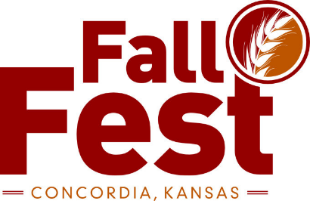

2020 5K Run

Sponsored by Cloud County Choppers 10 & U Baseball Team

Saturday September 26, 2020 7:00 a.m.

Concordia Kansas

**Entry Fees:** Pre-registration date is September 15th to guarantee a T-shirt but will take pre -registration up to September 20th.

$15.00 Pre-registration/$20.00 Day of Ru

Place/Event times: Broadway & 7th Street

6:30 a.m. Registration

7:00 a.m. 5 K Start

Send Entries and Make Checks Payable to : Cloud County Choppers

316 W 15th

Concordia KS 66901

NAME:_____________________________________EMAIL:____________________________ADDRESS:_____________________________________________________________________PHONE:___________________________M/F____________AGE ON 9/26/2020___________

Please circle T-Shirt size (Adult sizes): **S M L XL XXL**

By my signature below, I hereby approve and authorize the use of my name and photograph/motion picture in any connection with the 5K Fall Fest Run. Further, I release all Run sponsors, organizers, workers and volunteers from any and all liability for accident, injury, death, or damages of any kind incurred by me arising from my participation in this activity. I affirm that I have prepared for this event through exercise, training, and nutrition/hydration. I have not been advised by a medical professional, to avoid strenuous exercise. I understand that there will be traffic on the course and I assume all risks from such traffic. I further assume any and all risks from falls, collisions with other participants, and from wild or domestic animals. I take this action voluntarily, for myself, my executors, administrators, heirs, next of kin and successors.

**_____________________________________ ___________ ________________________________**

**Signature Date Parent signature (if under 18)**

**Fall Fest Fun Run**